HIMSS 2017 第三天

1．Semantic Data Analysis for Interoperability

在诊疗过程中，会产生大量来自EMR、EHR、Report等的文本数据，这中间很大一部分数据又是非结构化，尤其是自由书写的文本。如何综合处理这些数据，从而自动抽取出有用的信息是这个讲座的主要目的，这里用到的语义分析的方法也是一个很专门的领域。

讲座中提到的语义分析过程是，首先将连续的文本离散化成一个个语义单元，然后用既有的语义对这些单元做语义映射，加上标签，最后转化成系统可以识别的结构化数据。讲座中离散化过程用到了BFO框架，下一层OBI和OGMS是有语法含义的实体，两者是从不同角度划分的，感觉OGMS是有诊断含义的语义，如具体的什么病、症状、病程、具体的诊断等。

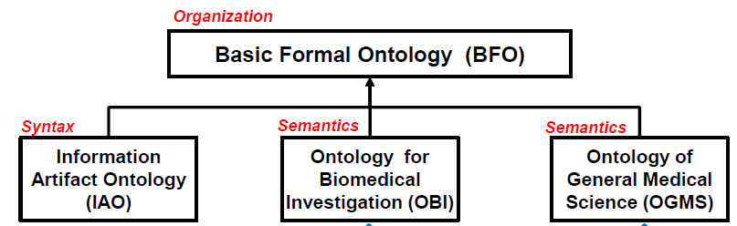

**Note(from wiki)：**The **Basic Formal Ontology** ([BFO](http://www.ifomis.org/bfo)) is a formal ontological framework developed by [Barry Smith](https://en.wikipedia.org/wiki/Barry_Smith_(ontologist)) and his associates that consists in a series of sub-ontologies at different levels of granularity. The ontologies are divided into two varieties: **continuant** (or snapshot) ontologies, comprehending continuant entities such as three-dimensional enduring objects, and **occurrent** ontologies, comprehending processes conceived as extended through (or as spanning) time. BFO thus incorporates both three-dimensionalist and four-dimensionalist perspectives on reality within a single framework. Interrelations are defined between the two types of ontologies in a way which gives BFO the facility to deal with both static/spatial and dynamic/temporal features of reality. Each continuant ontology is an inventory of all entities existing at a time. Each occurrent ontology is an inventory (processory) of all the processes unfolding through a given interval of time. Both types of ontology serve as basis for a series of sub-ontologies, each of which can be conceived as a window on a certain portion of reality at a given level of granularity.

语义映射描述了既有语义和待分析语义单元之间的关系，主要有接近、完全相同、是一个、是部分等关系。

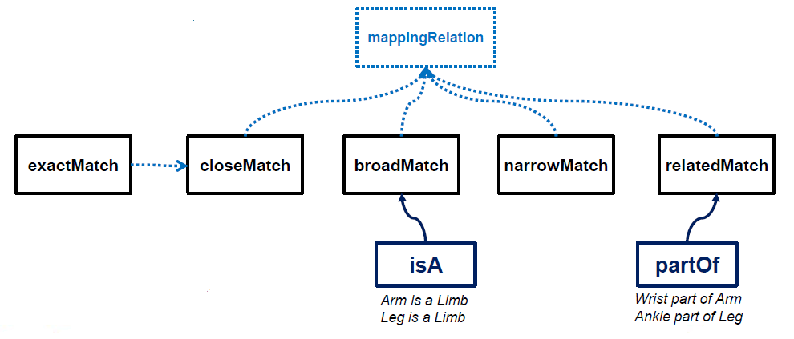

下图是讲座中提到的一个三层结构，上边两层感觉是比较抽象的实体，最下层是具体的，有含义的实体。其中SNOMED, ICD, CPT, RxNORM ,LOINC是医疗领域中的一些编码规范。

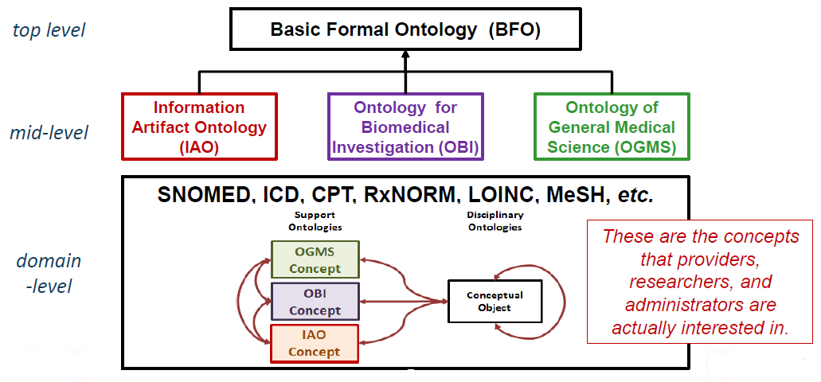

**Note(from internet):**

ICD-9 Codes – International Classification of Disease

The International Classification of Disease (ICD) is a widely recognized international system for recording diagnoses. It is developed, monitored, and copyrighted by the World Health Organization (WHO). Applied to any diagnosis, symptom, or cause of death, ICD consists of alphanumeric codes that follow an international standard, making sure that the diagnosis will be interpreted in the same way by every medical professional both in the U.S. and internationally.

The current version of ICD used in the U.S. is known as ICD-9, though it’s in the process of being replaced by ICD-10. Rather than simply being an updated version of ICD-9, ICD-10 is a more comprehensive and complex set of codes designed to address some of the issues of ICD-9. For example, ICD-10 codes are longer than ICD-9 codes, reducing the risk of running out of possible available codes in the future. They are also more detailed, registering finding like laterality (which side of the patient a symptom appears on), an option that has been previously absent in ICD-9.

ICD-10 is scheduled to replace ICD-9 in the U.S. starting October 1, 2015.

CPT Coding – Current Procedural Terminology

Free Demo - Award Winning MediTouch EHR and Billing SoftwareWhat is a CPT code? Current Procedural Terminology (CPT) coding is a U.S. standard for coding medical procedures, maintained and copyrighted by the American Medical Association (AMA). Similar to ICD coding, CPT coding is used to standardize medical communication across the board – but where ICD-9 and ICD-10 focus on the diagnosis, CPT instead identifies the services provided, and are used by insurance companies to determine how much physicians will be paid for their services.

CPT is managed by a CPT Editorial Panel, which meets three times per year to discuss current issues related to new and emerging technologies, as well as difficulties encountered with procedures and services as they relate to CPT codes. The AMA offers many products and services to provide guidance and advice, and to help you improve your understanding of CPT codes. Individuals may apply for new CPT codes or change existing CPT codes by submitting proposals to the CPT Editorial panel.

LOINC – Logical Observation Identifiers Names and Codes

Logical Observation Identifiers Names and Codes (LOINC) was created in 1994 by the Regenstrief Institute as a free, universal standard for laboratory and clinical observations, and to enable exchange of health information across different systems. Where ICD records diagnoses and CPT services, LOINC is a code system used to identify test observations. LOINC codes are often more specific than CPT, and one CPT code can have multiple LOINC codes associated with it.

Currently, more than 26,000 people in 157 countries are using LOINC, and it has been recognized as the preferred standard for coding testing and observations in HL7.

SNOMED CT – Systematized Nomenclature of Medicine

SNOMED Clinical Terms (SNOMED CT) is a comprehensive, computerized healthcare terminology –containing more than 311,000 active concepts – with the purpose of providing a common language across different providers and sites of care. As a core EHR terminology, SNOMED CT is essential for recording clinical data such as patient problem lists and family, medical and social histories in electronic health records in a consistent, reproducible manner.

由于这个讲座涉及到的是一个很专的领域，基本上没有听太懂。

2．How Location Intelligence Adds Value to Healthcare Operation

环境因素对人的健康至关重要，对环境因素的分析是健康管理很重要的一部分。而在健康管理中对地理位置信息的收集和分析，会对环境因素分析带来很大的帮助，比如所在位置周围的餐馆情况，可能对饮食习惯产生影响，所在位置人群聚居的情况，可能对一些生活习惯有影响。

这个讲座中介绍了一个移动健康管理系统，以及在其基础上构建出来的一个健康管理生态系统。

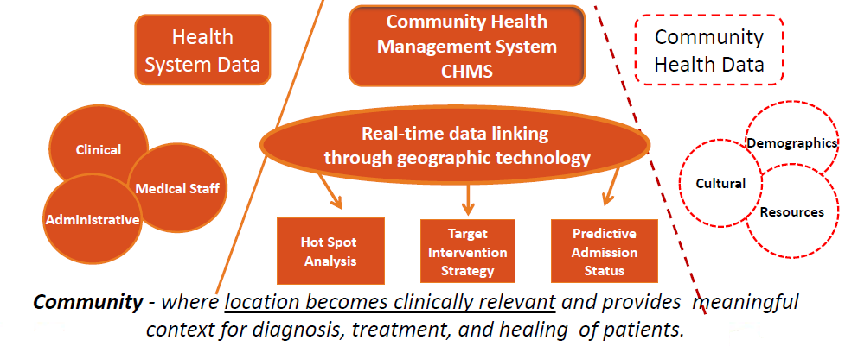

主要的工作流程如下：

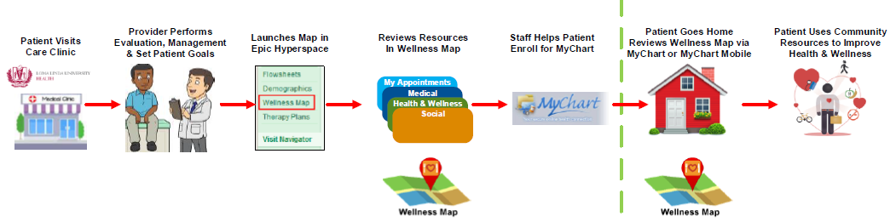

3．Using Big Data to Reanimate a Paralyzed Limb

这个讲座介绍了一个使瘫痪病人的手臂重新重新活动起来的案例。首先通过fMRI找到控制手臂运动的区域，在大脑中植入微电极阵列收集大脑皮层信号，并把信号传递给计算机处理，处理完成的信号传递给手臂上的一个电极套，发出相应的电信号刺激手臂运动。

正常人大脑信号通过脊髓里神经传导到手臂，刺激手臂肌肉产生运动。

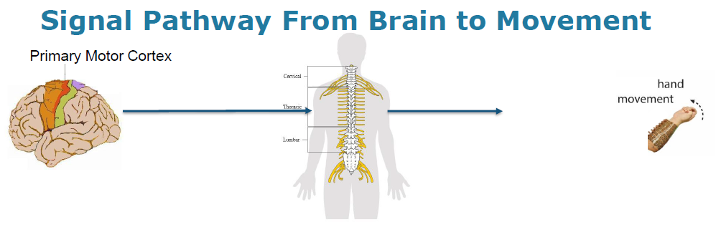

脊柱中神经受损，信号通路中断，通过微电极阵列收集大脑皮层信号传递给计算机，绕过原有不通的传导路线

